***Visualization Tool For Electric Vehicle Charge And Range Analysis***

1. **INTRODUCTION**
   1. **Overview**

Fuel is very important for day to life usage. Alternative energy sources have a much lower carbon footprint than natural gas, coal, and other fossil fuels. Switching to renewable energy sources to produce electricity will help the planet by slowing and reversing climate change.

* 1. **Purpose**

Electric vehicles use electricity to charge their batteries instead of using fossil fuels like petrol or diesel. Electric vehicles are more efficient, and that combined with the electricity cost means that charging an electric vehicle is cheaper than filling petrol or diesel for your travel requirements.

1. **PROBLEM DEFINITION AND DESIGN THINKING**
   1. **Empathy map**

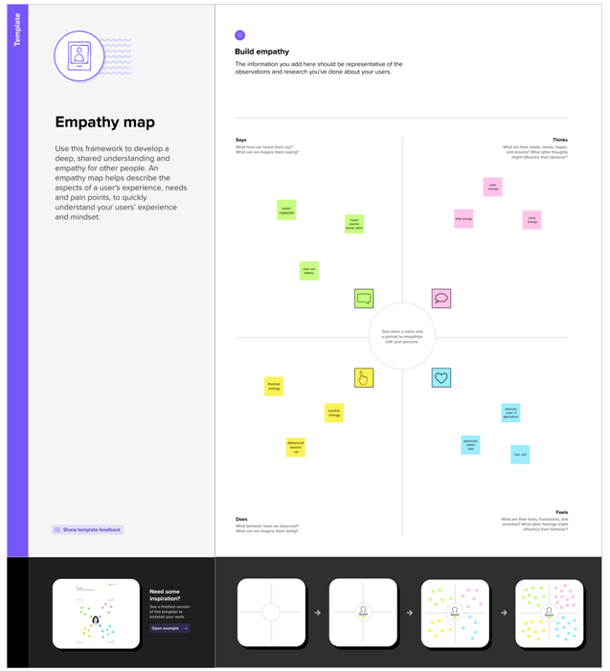

* 1. **Brain storming map**

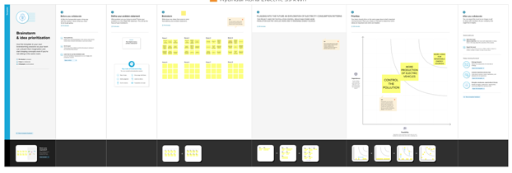

**3.RESULT**

This data may include the information about Electric Vehicle Charge And Range Analysis around India for different regions.

All over the Indian Toyota PROACE Verso L 75 kWh electric Vehicle has the more better than other.

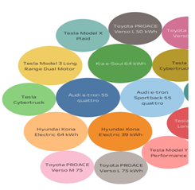

1. **ADVANTAGES AND DISADVANTAGES**

**Advantages**

* **Low Noise Pollution**
* **No Fuel**
* **Natural Resource Saving**
* **Secure Environment**
* **Low Maintenance Cost**
* **More Convenient**

**Disadvantages**

* **Higher Purchase Cost**
* **Low Energy**
* **Battery Expenses**
* **Expensive Recharging Options**
* **Slow Charging**
* **Low Speed and Range**
* **The Inconvenience of Service Station**

1. **APPLICATIONS**

It is used in the electric motors, batteries, inverters, wiring and in charging stations because of its durability, malleability, reliability and superior electrical conductivity.

1. **CONCLUSION**

So, in conclusion, electric cars have both advantages and disadvantages. They are a great way to minimize environmental pollution and reduce fuel usage.

1. **FUTURE SCOPE**

This may be helpful fuel consumption an electric vehicle in the future.